**1] Department of English**

**1) Workshop on Personality Development Dr.Rakesh Wasnik from Yashwantrao Chavhan College Lakhandur Presenting his views- Date – October 07-2019**

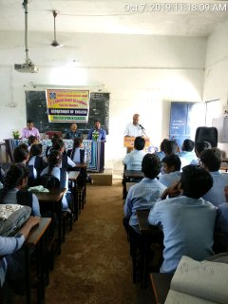

**2) Guest Lecture on Communication skills Date – October 07-2019**

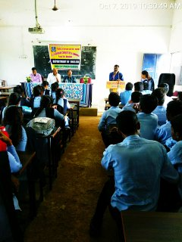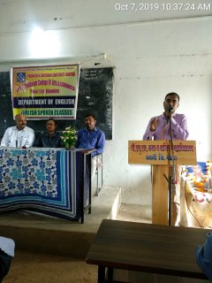

***4) Poster Exhibition (A Background to the Study of English Literature) Date February 10-2020***

